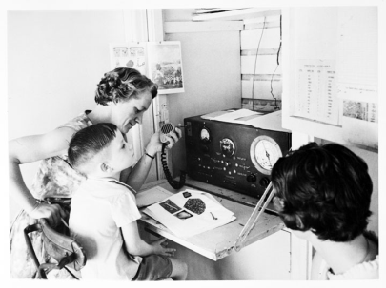
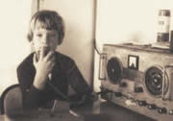
School on the air

School on the air is a service used by many Australian children who live in the outback. Because Australia is so large and many people live far from schools in the country, they must stay at home and receive their school lessons over the radio.
The idea was thought of by Miss Adelaide Miethkein 1946 and allowed many school children who went to boarding schools or used letters to do school work to study at home with their families and have a better education.
School on the air began in 1946 and in a few years, the idea had spread through most of Australia’s bush land.
In 2005, there were 16 schools of the air providing primary education to children.
Recently schools have opened which allow secondary school classes and some adult courses to be taught as well.
Currently many teachers try to visit all their students during the year and even organize sports events to help their students meet their fellow classmates.
Normally students will visit their school a few times every year to use the school’s facilities and attend graduation day.
Increased access to the Internet has helped many students study on line instead of using the radio and has made learning far more interactive.
Teachers are now able to see, speak and listen to all their students even though they are hundreds of kilometers away.

