BTS NDRC Cas Mise en Situation de Communication 2020/2021
Attendus:
L’accélération de la digitalisation des activités commerciales conduit le titulaire du BTS NDRC à investir les contenus commerciaux liés à l’usage accru des sites web, des applications et des réseaux sociaux. Recommandations, avis, notations sur les réseaux sociaux, forums, blogs deviennent de fait des vecteurs de communication que le commercial doit intégrer pour développer la clientèle et avoir une forte réactivité.

E-commerce and networking | Real Estate | Tourism and Wine vacations / wine holidays | Innovations (communications and transport – sustainable development)
Community manager (social networks)  webmaster  after-sale service | Real estate agent/salesperson  Broker / Realtor | Business development manager  Tour guide  Event manager  Wine club/e-commerce manager | Car sales representative  Logistics manager  Solar panels sales representative

Candidat :
Il présente une analyse du document support en lien avec le questionnement fourni - il identifie les besoins, en fonction de la cible, du contexte culturel, du lieu… Puis lors des échanges avec l’examinateur, il propose une démarche commerciale argumentée. L’examinateur l’invite à réagir, décrire, reformuler, développer son argumentation, justifier son propos ou encore apporter des explications La commission n’évalue pas la qualité de la réponse commerciale, mais l’aptitude à construire un discours argumenté et structuré. L’entretien et l’évaluation sont conduits dans un esprit positif et avec bienveillance. La durée n’excède pas 20 mn
La mise en situation est:
Une mise en situation et un questionnement prenant appui sur un document à caractère commercial (documentation produit, page écran de site commercial, plaquette de salon, offre d’emploi, etc.).
Source: BTS NRDC formation sur évaluation (ac-bordeaux.fr)
Table des matières
1. E- commerce and networking – Tourism and Wine tourism - Community manager 3
2. E-commerce and networking – Webmaster 4
2. bis - E-commerce and networking – Webmaster – Examiner 5
3. Ecommerce and networking / Innovations– After Sales services 7
4. Real Estate – Real Estate Sales consultant. 8
5. Real Estate – Real Estate Agent/ sales representative 9
6. Real Estate – Broker / Realtor 10
7. Tourism and Wine vacations / wine holidays - Wine sales representative in a wine shop 11
Capture the Stormhoek moment 11
7. Tourism and Wine vacations / wine holidays - Wine sales representative in a wine shop – Examiner 12
8. Tourism and Wine vacations / wine holidays – Business development manager 13
8. Tourism and Wine vacations / wine holidays – Business development manager - Examiner 14
9. Tourism and Wine vacations / wine holidays - Event manager 15
10. Tourism and Wine vacations / wine holidays - Wine club/e-business manager 16
10 bis. Tourism and Wine vacations / wine holidays - Wine educator / Tour guide / Wine club manager -Examiner 17
11. Innovations (communications and transport – sustainable development) - Car sales representative (sujet 0) 18
12. Innovations (communications and transport – sustainable development) - Logistics manager 19
13. Innovations (communications and transport – sustainable development) - sales representative 20
14. Innovations (communications and transport – sustainable development) - sales representative 21

1. E- commerce and networking – Tourism and Wine tourism - Community manager
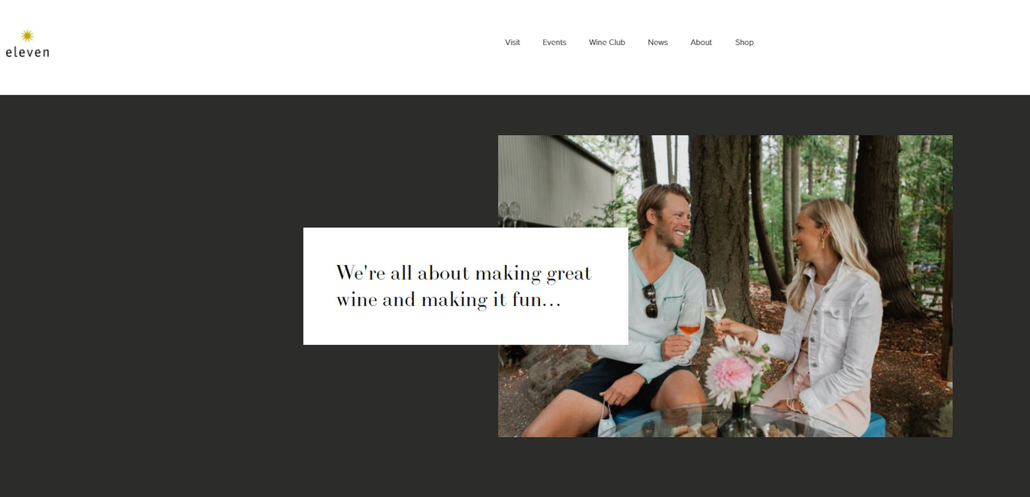
Anyone who tells you that wine tasting is serious business or makes you feel bad about your level of wine knowledge is just plain missing the point - and we'll be more than happy to straighten them out for you. We'll also be happy to answer all of your questions about wine so that you can hold your own in party conversation with the snobbiest wine geek. We don't believe in dumbing down our wines for novice tasters – we believe that everyone can enjoy great wine and that the better the wine, the more fun you'll have.
Our production highlights somewhat offbeat varieties – Mourvèdre, Lemberger, Chenin Blanc, Roussanne – as well as more well-known favorites (Syrah, Pinot Grigio…). Our cutting-edge winemaking processes are risky, dangerous, and often painful, but the wine is worth it - ok, it's not actually all that risky or dangerous, and it is far more traditional than it is modern, but it is challenging and exciting, and we're thrilled to be able to share the results with you. Come grab a glass and join us for GREAT WINE FUN!

Source: Eleven Winery

Situation: This is Eleven Winery’s website. They need someone to improve it. You meet the owners as a freelance community manager and offers them to hire you for this purpose.

Take the following hints into account:
- implement social media and online communication campaigns
- Build relationships with customers, potential customers, industry professionals and journalists
- Outside of the website, organize and participate in events to build community and boost brand awareness

2. E-commerce and networking – Webmaster
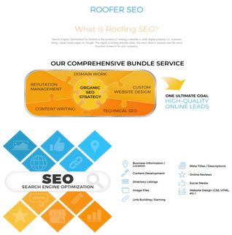
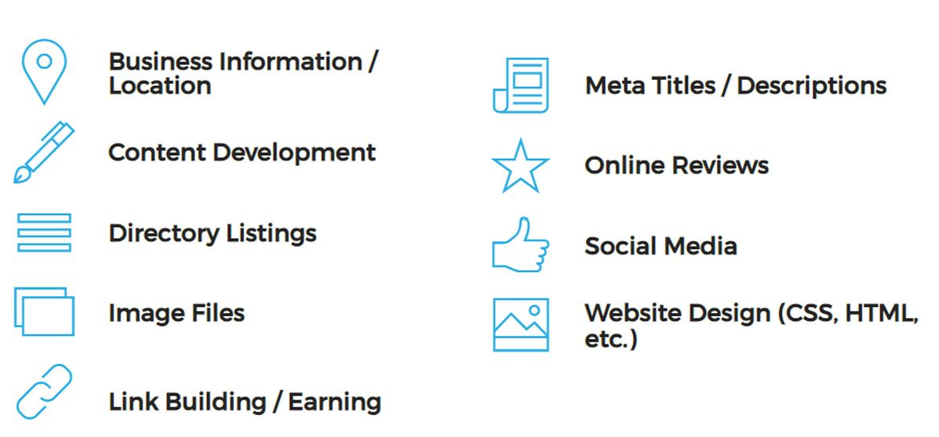
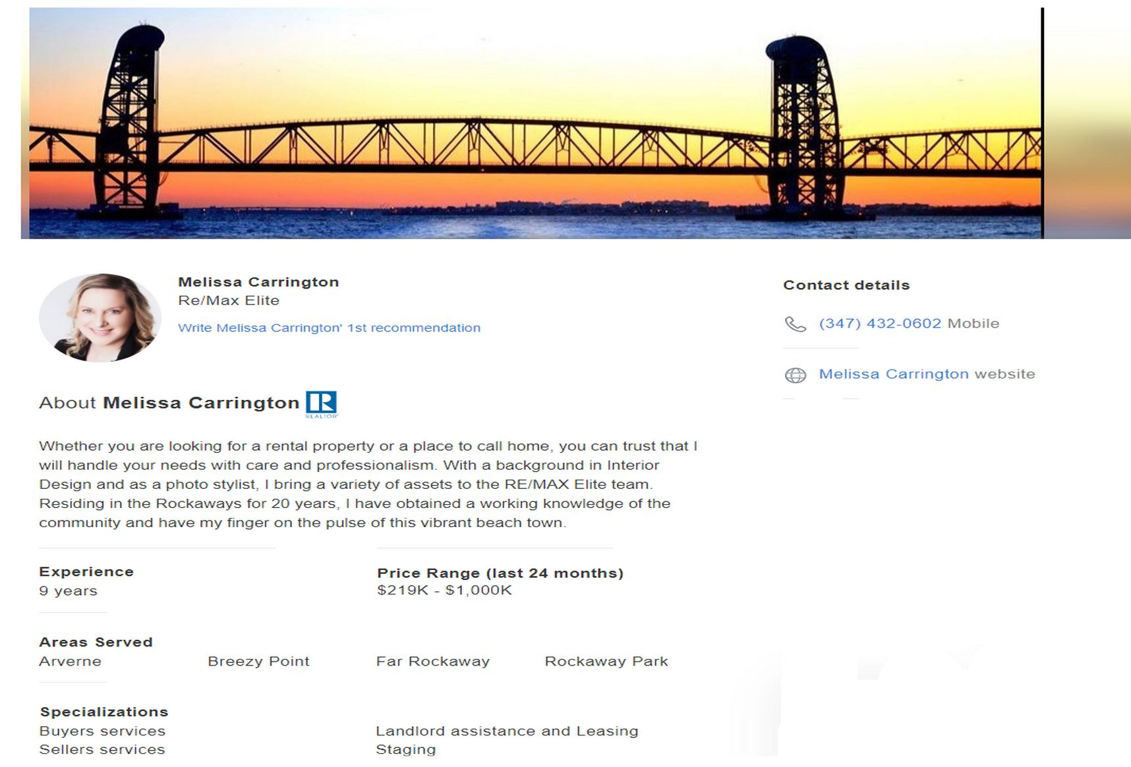

Source: Roofing SEO Webmasters | #1 Roofer SEO Service in 2021 (roofingwebmasters.com)

Situation: You work for roofing SEO and a Realtor has called you to improve his visibility on internet.
You will be responsible for making her/his/their website easy to use, attractive and secure.
In this role, you should be detailed-oriented and an excellent communicator. Balancing a creative eye with an analytical mind is essential. If you also have a strong technical background, we’d like to meet you. Ultimately, you will ensure the functionality and efficiency of web infrastructure.
Take into account the following hints:
- What is your role in designing a new web page?
- What would you check first if many users complained about the website load speed?
- What web management tools would you use ?

2. bis - E-commerce and networking – Webmaster – Examiner
What Is Roofing SEO?
Roofing SEO is the process of increasing the visibility of a roofing business website. When users type in a search term and they are given numerous pages of results, it is likely they will select one of the top results. The goal of a roofing business is striving to have their site rank as high as possible. In order to do this, several attention-grabbing methods need to be employed. Keep in mind that great SEO is about appealing to search engine bots as well as the individuals who are conducting the searches. You should never focus on one of them more often than the other.
On Page Roofing SEO Process
On Page SEO is all about optimizing each page of your site in order to drive more phone calls and traffic your way. Here are some of the methods you can use in order to do this, along with a brief description.
Keyword Research
This is one of the most important parts of roofing SEO. You need to do some research to determine the best keywords for your business. Keep in mind that shorter keywords are fine, but using longer terms is extremely useful. For instance, “roofing company” is fine, but “roofing company in Anytown, US” is more specific and can attract a better audience.
Meta Title: This is the part of the website that tells users what page they are on. This should be free of errors and to the point with at least one keyword integrated into it.
Meta Description: A small blurb that describes the content of the page. It should be no more than 155 characters long. It appears in search results beneath the meta title.
Meta Tags: These describe the page, but they are not visible to users. They are part of the website’s code. These are strictly there to attract search engines.
Page Speed: It should take no more than 3-5 seconds for each page to load.
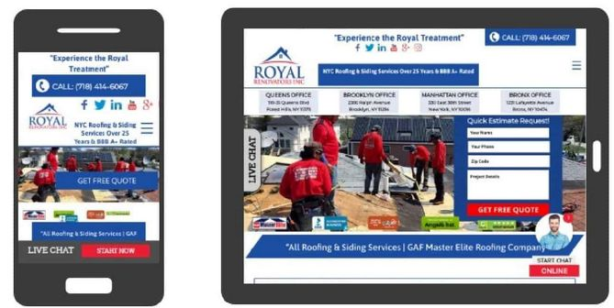
Alt Text for Images: Since search engines cannot view images, you can add these to image tags in HTML to give them an idea of what the picture contains.
Mobile Optimization: Most people use mobile devices to access the Web. You have to make sure that they are able to view your site without any problems.
URL Structure: The URL structure throughout your website needs to be consistent. It should also be simple enough for people to remember, yet unique enough to distinguish you from others.

Site Map: This is a map that details every part of the site and a link that directs users there. Those who find themselves lost in the pages of a site can refer to it in order to find their way. Even if your site seems easy to navigate, include it anyway.

Off Page Roofing SEO Process: These are activities that take place outside of your website, yet they help immensely when it comes to boosting traffic numbers. Here is a bit more information:

Backlinks: This is when a link on a website leads you to another website. You can trade these with those in your niche in order to increase your popularity.

How Your Roofing Business Website should be structured for SEO
When you are creating your website, there is a certain structure that must be followed if you want to do well. Here are all of the components that must be present if you expect to succeed.

Well Designed/Up to Date Website:
There is no way around this. You have to provide your audience with a user-friendly site that is aesthetically pleasing while managing to avoid being dated.

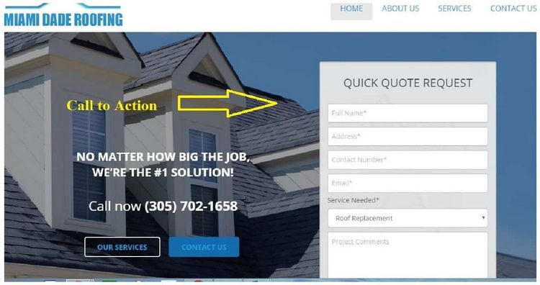
Call to Action On Top Of Your Website
You might think it is unnecessary, but some people need to be told what the next step is when they are on your website. Should they call you for more information? Is it a good idea to fill out an online form in order to receive a quote? Instead of allowing them to play a guessing game, you need to let them know what to do.

A Picture of Your Team on the Homepage
A roofing company needs to be transparent and establish trust with its potential audience. Providing everyone with a picture of your team will be very useful for this purpose.


Licenses and Certifications on the Website:
Most people will ask to see this information before doing business with you. This is a way to let them know that you are qualified ahead of time while saving them a lot of time and trouble.

Testimonials/Portfolio
People want to know that there are others out there who have used your services and achieved satisfaction. A portfolio of roofing work you have done in the past and/or testimonials from people who were pleased with their experiences would be very useful. In fact, consider setting aside a page on your website for this.

Conclusion
There is a great deal for you to think about when it comes to the SEO aspect of your roofing business. Now that you have all of this knowledge at your fingertips. It is time for you to put it to good use. Doing it well means that you may end up with one of the best roofing companies around.
Source: Roofing SEO | All you need to know before getting started (growyourevenue.com)

Part of the correction can be find here:
Melissa Carrington - Brooklyn, NY Real Estate Agent | realtor.com®

3. Ecommerce and networking / Innovations– After Sales services

Our Mission: Defines Our Company
EnergyPal’s mission is to provide quality energy solutions at lower prices. Our company helps homeowners choose the best solar & home battery systems and save time, money and avoid hassle. Simply, better solar for less. We are situated in Toronto, Canada.
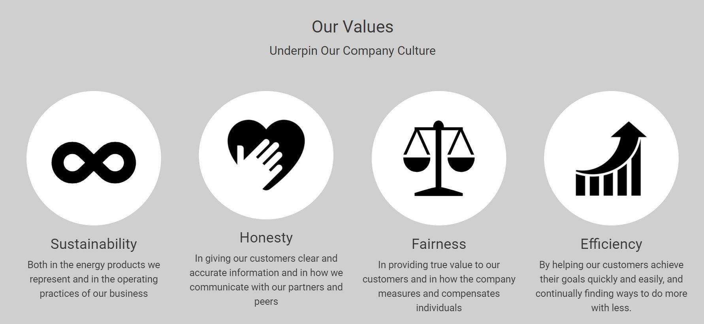
Our Commitment: What to Expect
Our customers enjoy group deals, personalized touch and our guarantee. We’re solar experts focused on helping homeowners get quality energy solutions at lower prices. We assign a single energy expert to each one of our customers and ensure:
- You receive the best deals on top-rated solar and batteries...
- You get the facts and guidance to select the best for your home...
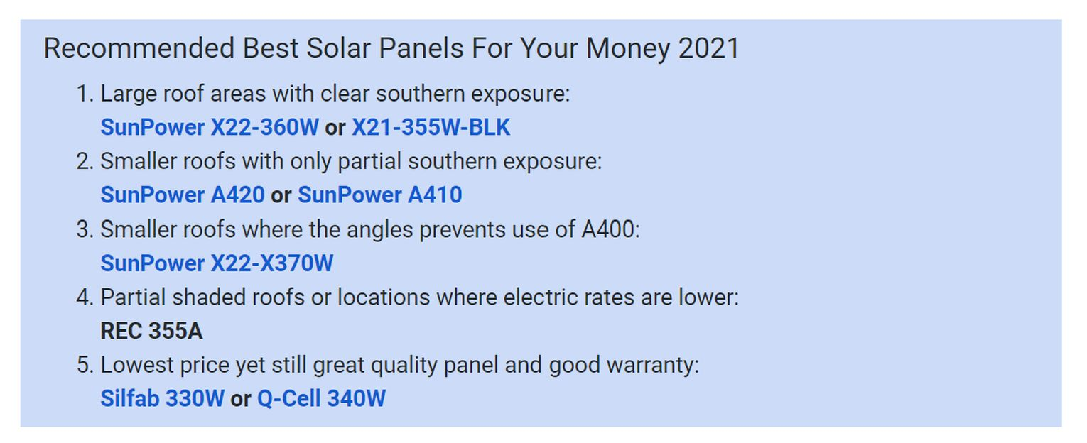
- You have the expert support to make sure you are satisfied.
Best Solar Panels for The Money
The best solar panels for the money in 2021 depends on the specifics of your home location and roof characteristics. We’ve summarized this down for you based on our review of all available solar panels.
Source: EnergyPal - Our Solar & Home Battery Company
Situation: You are an after sales representative for a solar panels and batteries provider. Your receive a client who is dissatisfied with his 10-years old solar panels, provided by EnergyPal.
Take into account the following hints:
- Take into account the customer’s request and make him/her feel welcome.
- Offer an installation that will provide him/her with a better solution.
- Make sure that he/she has all the information needed to take the right decision and offer a follow-up.
After sales services advices for students: After Sales Service / Customer Service (managementstudyguide.com)

4. Real Estate – Real Estate Sales consultant.
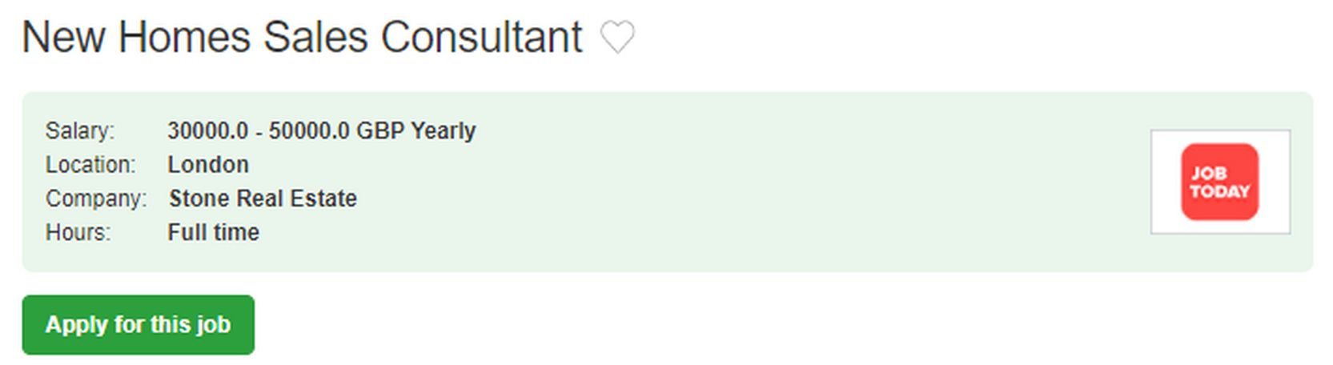
· Become a major part of a fantastic young property company in London looking to double turnover in 2020!
· Receive on the job training from internal and external experts – a full industry and company induction
· Learn how to become a top salesperson and gain a set of skills for life
· Solely focus on selling new homes across London
· Fitness benefits and perks are provided, as well as target driven individual and team rewards.
· No property experience needed - just bring an excellent work ethic and drive
· Be prepared to look fantastic in a suit!
· The focus is on face to face meetings – rapport and relationship building.
· All warm leads – no cold calling!
The Role:
• A quite remarkable and innovative sales consultancy role based in Central London near Tottenham Court Road, which covers London as a whole.
• The process includes face to face meetings, phone work, and lead management
· All WARM enquiries for new homes, including Help to Buy properties and up to £2m+ luxury new homes
• Opportunity to join an expanding company with incredible investment, backing and imagination
• Major opportunities for progression and promotion to senior roles.
The Person: The Values:
Our sales team is growing rapidly to meet demand, providing opportunities for future leaders to shape the business moving forward.

Source: New Homes Sales Consultant Job in London (adzuna.co.uk)

Situation: You apply for this position as a sales manager for a London real estate agency. You have been selected for a zoom interview and you definitely want this position.

Take the following hints into account:
- Identify the positive sides of this position in accordance with your career plan
- Link this job to your experience
- Present an online development plan including social media and brand awareness

5. Real Estate – Real Estate Agent/ sales representative
4 Units - Fixer/Renovation super investment opportunity

Exclusive private offering.
OFF MARKET 4 units Property.
SUPER INVESTMENT OPPORTUNITY.
Great opportunity for a steady stream of cash flow.
Large 2 story home with secure gated front entrance and fruit trees.
2 bedrooms and half bath upstairs along with an extra bonus storage room.
Downstairs has 2 larger bedrooms and perfect for a large or extended family.
Zoning: LARD2
Lot size: 5,397 sqft
Building: 1,782 sqft
Detached Storage / Hobby Room converted to additional 2 units.
Potential rent income $7500-7700/m after renovation.
W 56th St,
Los Angeles, CA 90037
Priced $855, 000
fully occupied will worth over $1,2M .
Property is currently Vacant.
Home still has many of the original wood siding and beamed ceiling
inside as well as some minor modifications.
Property showing by appointment ONLY.


Situation: Your are a sales representative for Junior Real Estate Broker - Savills North America Los Angeles, CA.
. A seller has come to your office and wants advice to sell his/her/their house.
A few days later, a client has put an offer, but the price is 750,000$. Present the offer so that the client could accept it.

Take into account the following hints:
- Determine your client’s needs and financials abilities to propose solutions that suit them/him/her.
- Promote the sale of the property through advertisements, open house, and participation in multiple listing services.
- Act as an intermediary between buyer and seller once the offer has been made

For students: Real Estate Sales Agent Job Description, Duties and Jobs - Part 1 (careerplanner.com)

6. Real Estate – Broker / Realtor
Baird & Warner Real Estate
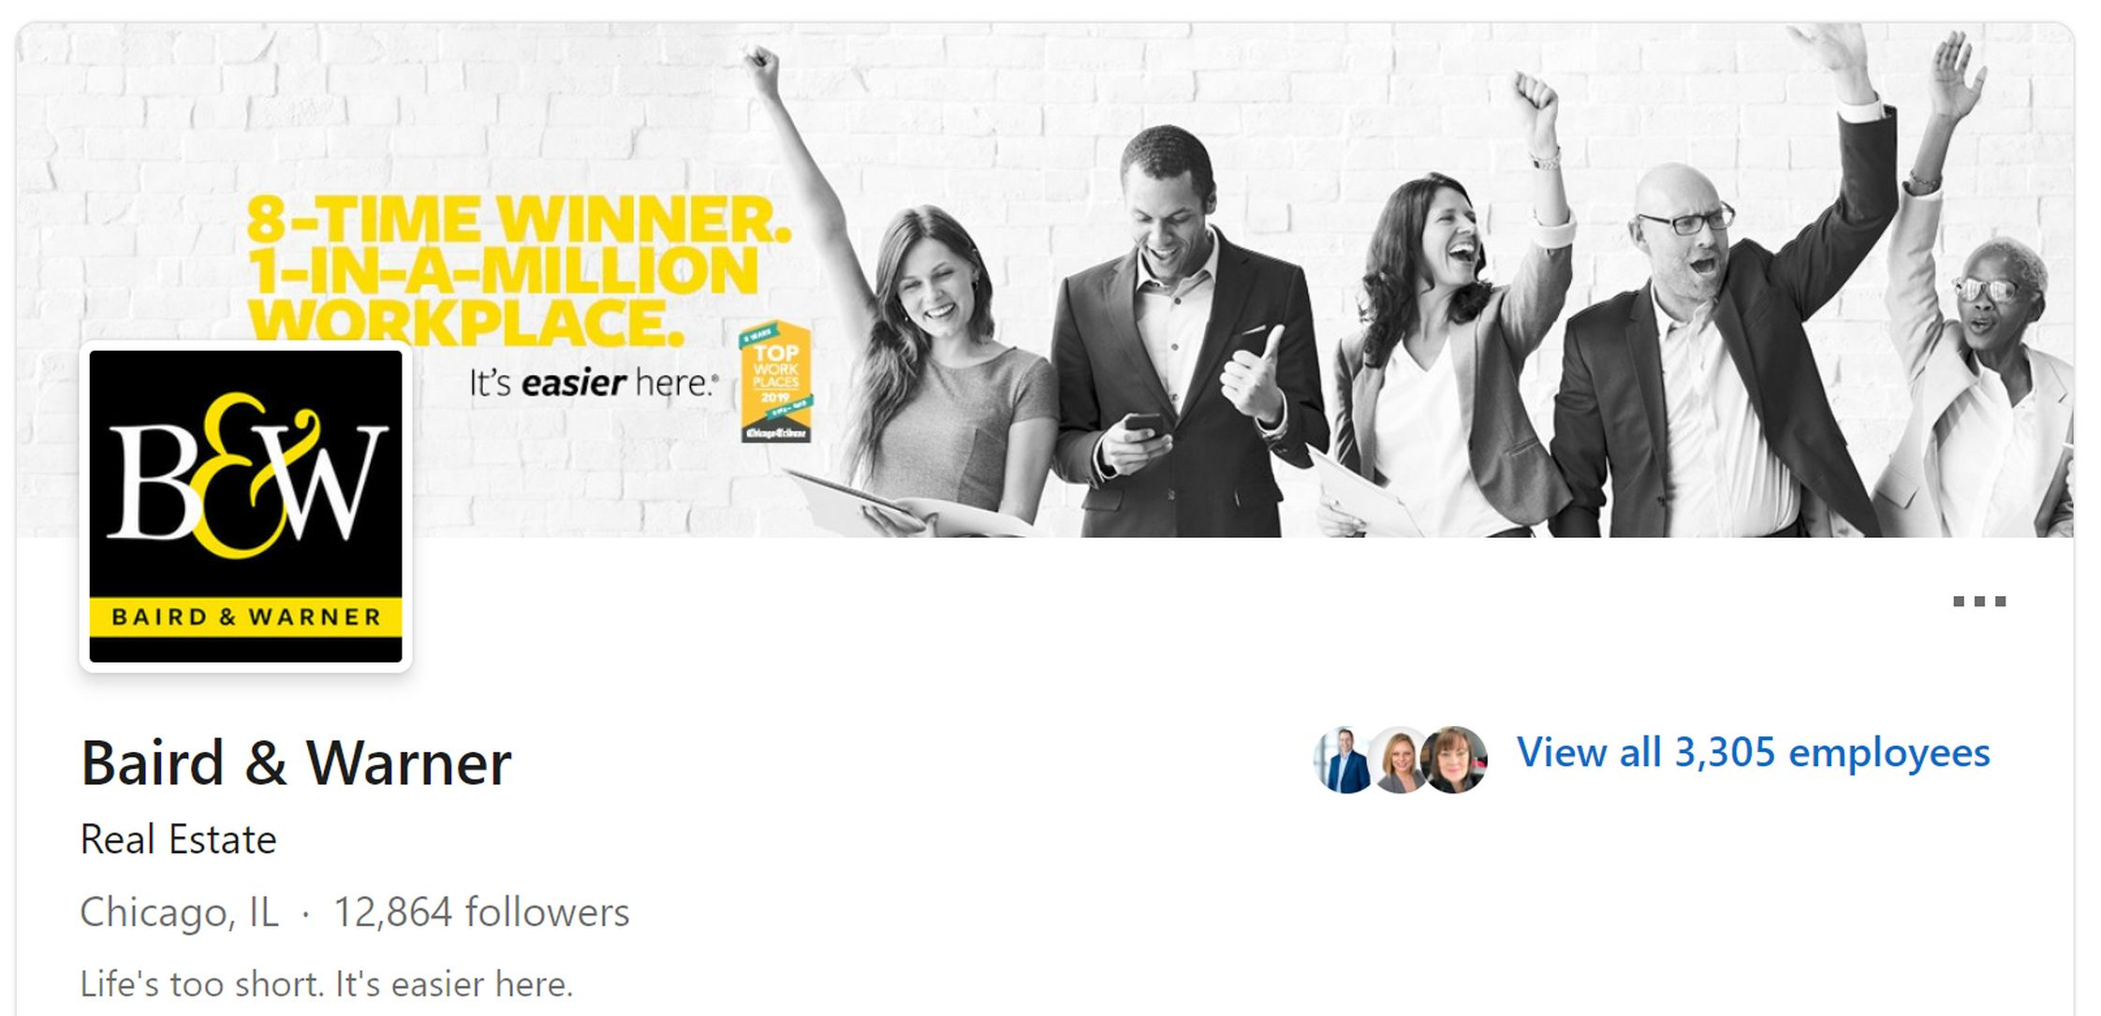
Website: http://www.bairdwarner.com
Industries: Real Estate  Company size: 1001-5000 employees  Headquarters: Chicago, IL  Type: Privately Held | Founded: 1855  Specialties: Residential Real Estate Sales, Key Mortgage Services, Inc., Title Services, Relocation Services, and Luxury Portfolio
Baird & Warner, Chicagoland’s leading residential real estate brokerage, is looking for a part-time Broker Assistant for our Northwest Suburban sales office. The Broker Assistant supports Realtors in the areas of social media posting, database management, marketing material production, clerical tasks, and more. Based on a progressive approach to administrative support, this role requires a skill set that includes a high level of comfort with technology, experience with social media and the ability to excel in a self-directed environment.
Applicants must be flexible in their availability. The Broker Assistant’s weekly work schedule is based on the demand of Realtors in need of support. Hours may vary from week to week. Work location is flexible, as some tasks can be performed remotely.
Requirements

- Computer skills including MS Office and Google platform  - Experience with social media platforms | - Highly organized, collaborative and dependable  - Ability to succeed in a self-directed environment  - High school degree or equivalent

Benefits
For 166 years, Baird & Warner has been making real estate easier for Chicagoland buyers and sellers — and creating a culture unlike any other for the people who work here. Just ask them the Chicago Tribune’s annual worker survey has named us a Top Workplace eight years in a row. Individual empowerment, enthusiastic innovation, and a true passion for giving back to our communities, makes thriving easy for our people and our company.

Seniority level: Associate / Employment type: Part-time / Job function: Administrative / Industries: Insurance / Financial Services - Real Estate

Situation: You apply for a position at Baird & Warner.

Take the following hints into account:
- Your experience during your internship.
- The social media campaigns that you are able to implement for them.
- The positive mindset that would make you a perfect applicant.

Sources: Chicago Real Estate | Homes for Sale - Top Real Estate Agent Chicago (bairdwarner.com)
For students: Real Estate Agent job description template | Workable Real - Estate Salesperson Vs. Broker (chron.com)

7. Tourism and Wine vacations / wine holidays - Wine sales representative in a wine shop

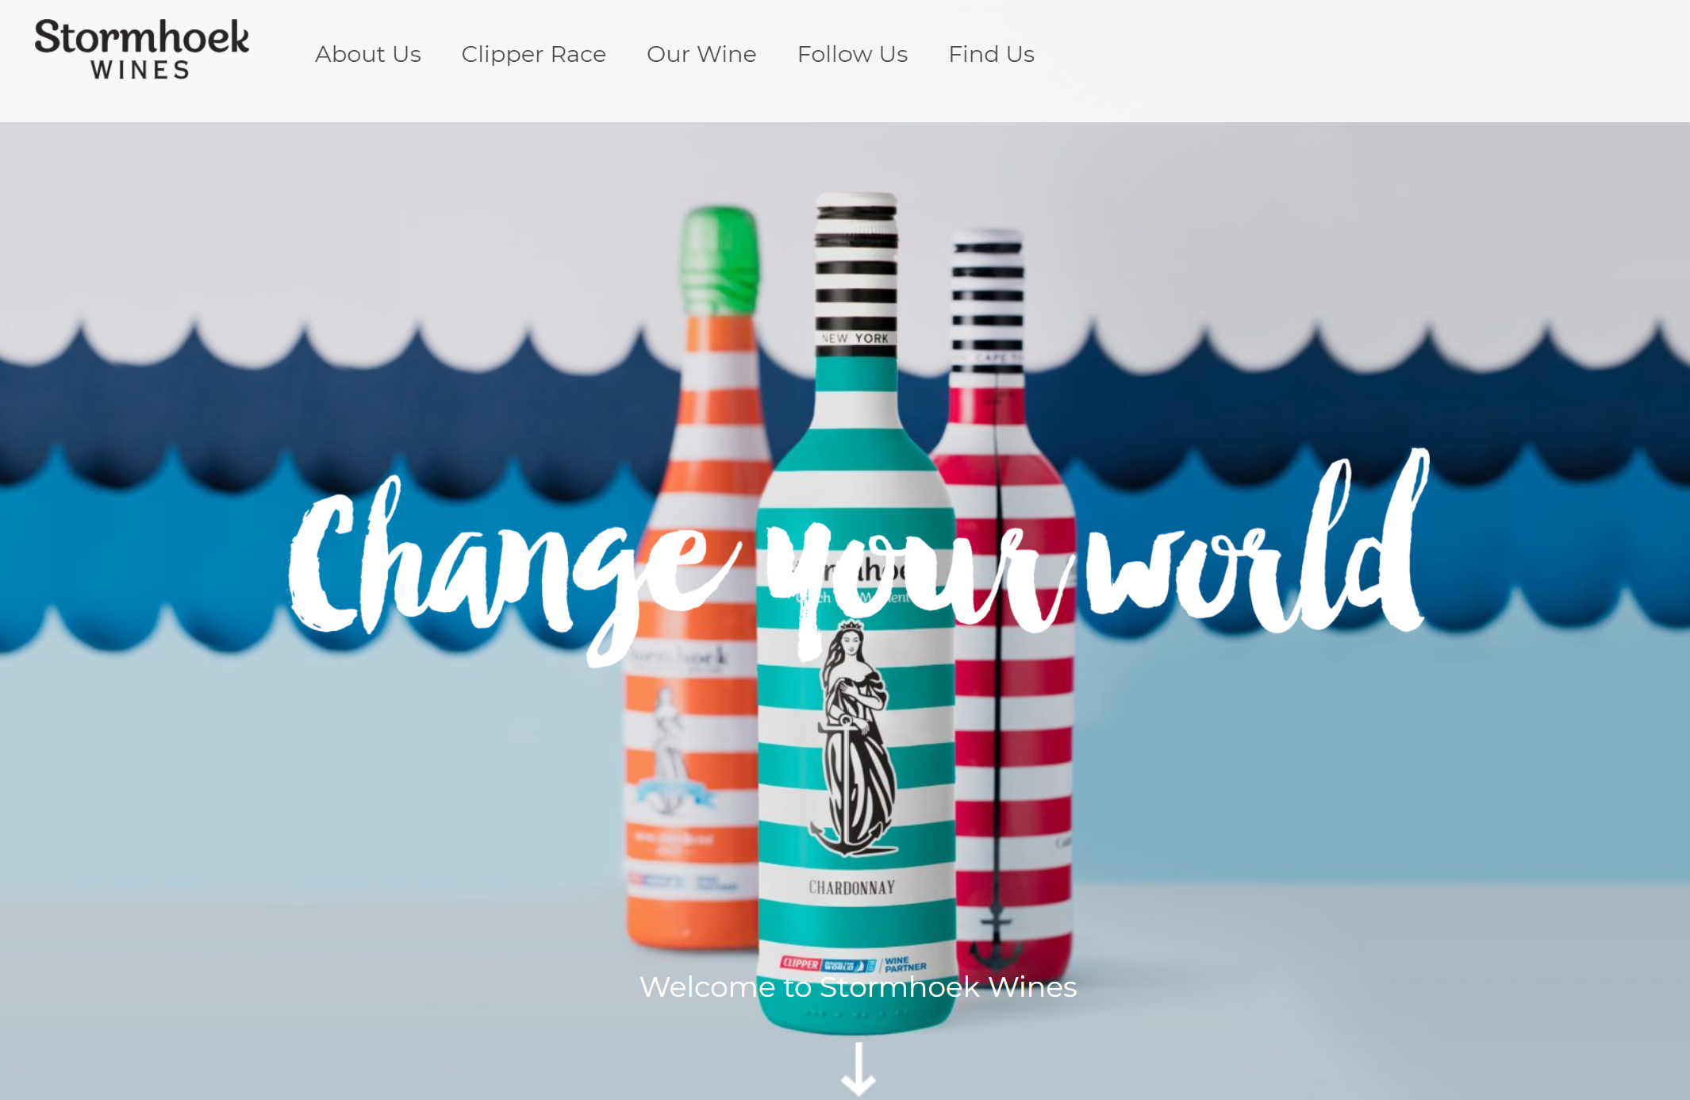
Capture the Stormhoek moment
People always say life is too short to drink bad wine. Well, we think life is too short to drink boring wine. That’s why Stormhoek is the wine that inspires you to imagine, discover and challenge yourself.
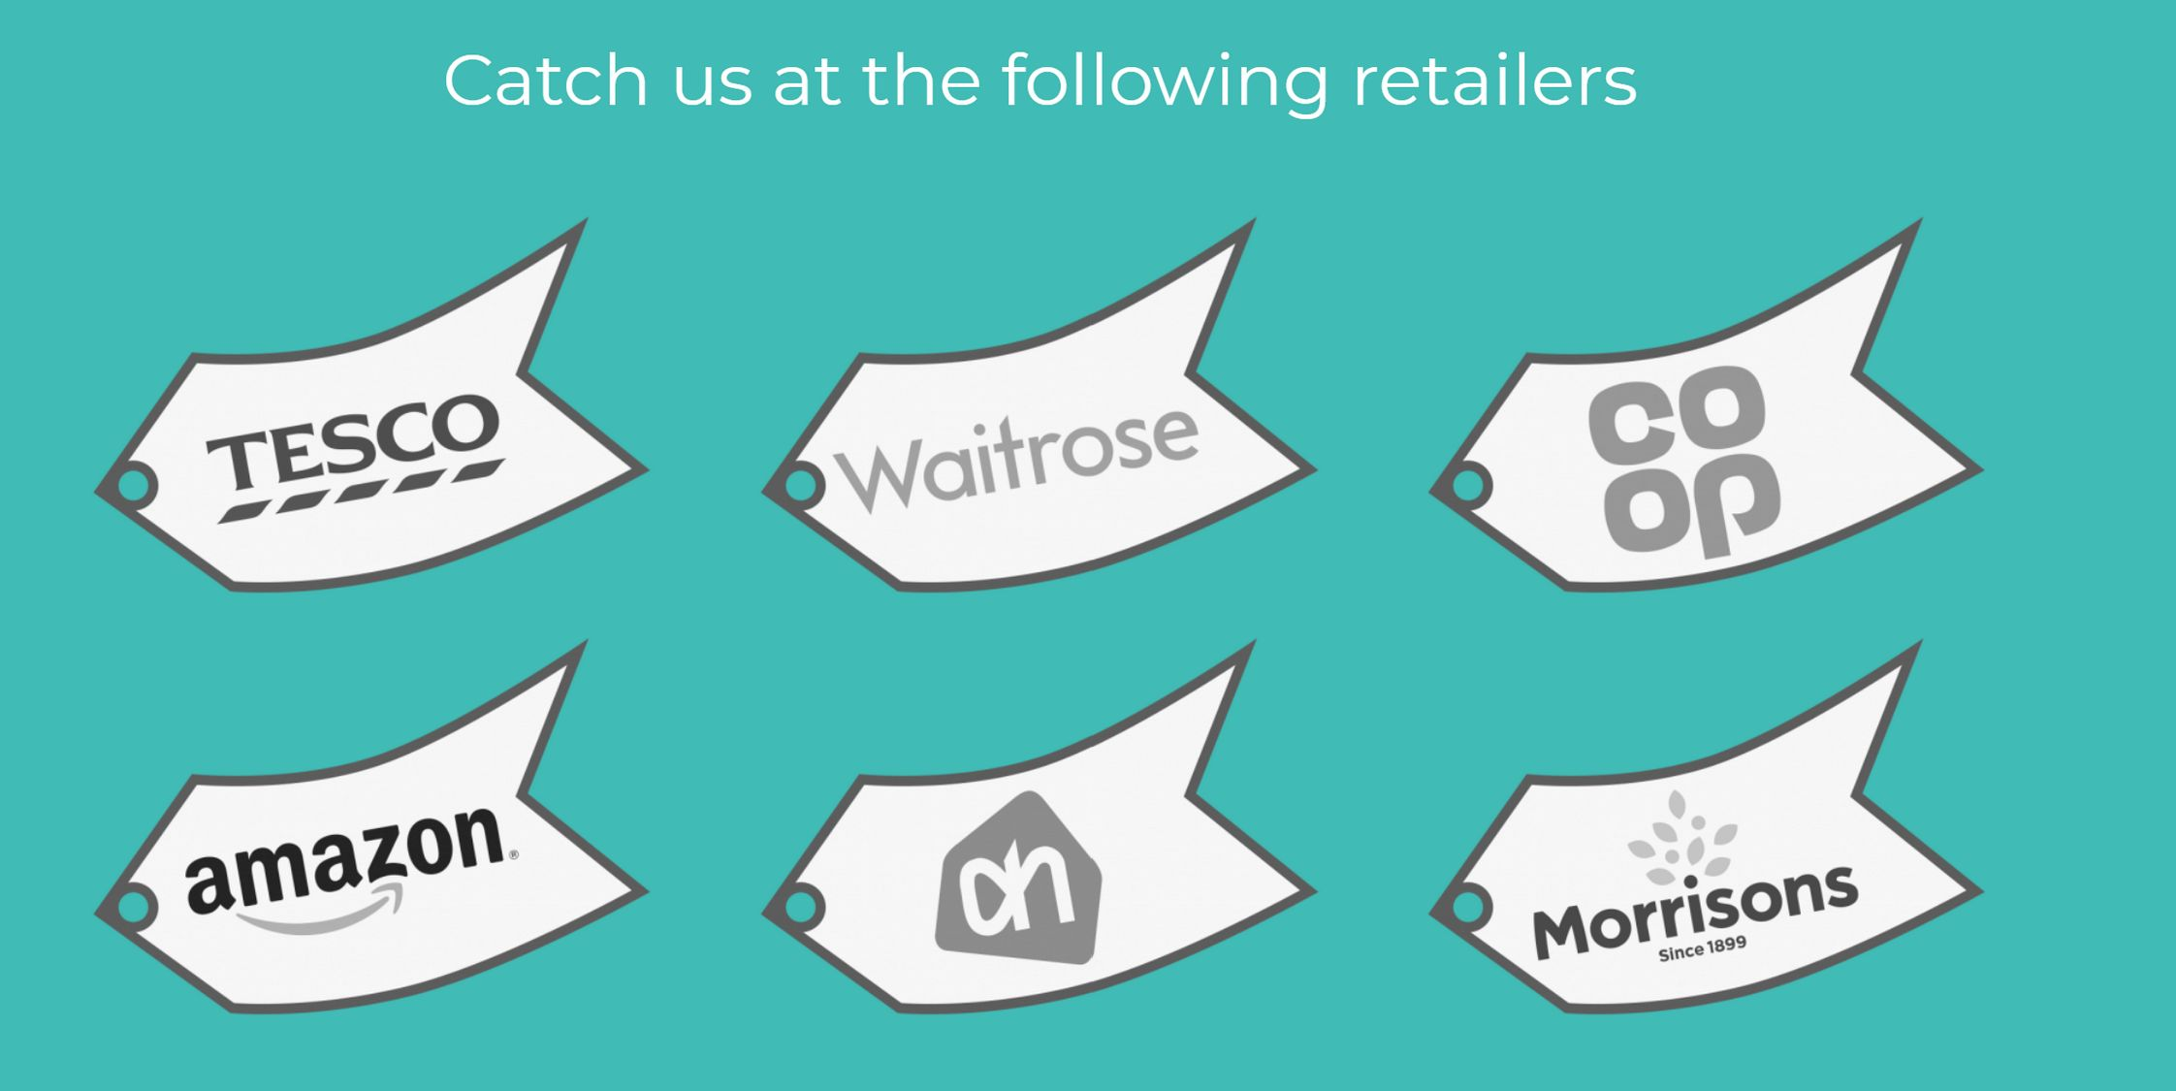
We believe that everyone has it in them to take the leap and change their something small about their world….and then the world around you! So, what are you waiting for?
Tired of all the choices you are being bombarded with every time to step into wine aisle? It’s time for a wine to step into the spotlight, and make the choice for us.
From South Africa’s Cape of Storms, Stormhoek Wines offers great quality across the range, leaving you more time for the important things in life: living life to the fullest!
Situation: You are a sales representative a Stormhoeck online wine shop in Western Cape (Cape Town) , South Africa. You are asked to lead an online campaign to increase Stormhoeck’s visibility on Social Media with a satisfying ROI.
Take the following hints into account:
- Promote the brand on social media
- Establish a plan to monitor the ROI of the campaigns you launch for the brand
- Structure the company for a proactive approach on social media.
Students’ resources: Five Examples of Social Media ROI in the Wine Industry (winebusiness.com) - Stormhoek Wines - Wine Sales Executive Job Description - Carling Partnership

7. Tourism and Wine vacations / wine holidays - Wine sales representative in a wine shop – Examiner
1. Stormhoeck Winery – One concrete example of a successful SM campaign is the case of the South African winery, Stormhoeck. They contacted wine bloggers over 21 years of age and with at least three months of blogging experience and asked if they wanted to receive a bottle of wine to taste. There was no requirement that the bloggers had to write about the wine. However, six months later over 100 bloggers published tasting notes and mentioned the wine on blogs all over the world. Stormhoeck then hosted a series of wine dinners in the UK, Spain, and the US to encourage personal interaction with the bloggers and prospective customers. The result was that wine sales increased from 50,000 cases a year to 300,000. In addition, Microsoft contracted with Stormhoek to create a special wine for its 79,000 employees in 102 countries (Resnick, 2008).

But you can also:
- establish a digital marketing division as part of the global marketing efforts,
- implement many online promotions and mobile coupons.
- invest in a social media campaign to educate Millennials about a specific winemaking
- launched a campaign to obtain media displays,
- institute tweet-up campaigns on Twitter and launch online wine videos.

Tips on Launching a Wine Social Media Strategy
Examples can be establishing a Facebook page and Twitter updates with regular monitoring and posting; creating intriguing online videos, writing humorous blogs, encouraging customers to post photos, and launching online coupons, promotions, and contests. This calls for a team effort and at least one person taking a leadership role to document results, though it may not be part of their formal job description.
A Targeted SM Strategy is another approach where funding is committed either to launch a social media campaign, such as the case of Pacific Rim and Stormhoeck, and/or to hire someone in at least a half-time role to implement and measure SM. With this strategy, clear objectives are set with a documented plan detailing which social media applications will be used and the desired results. Common methods to track social media in addition to sales are measuring website traffic, number of fans/followers, number of mentions, share of voice and tracking sentiment (Now, 2012).
A Formal SM Strategy involves hiring a full-time social media expert and/or establishing a department, as Constellation did with the Digital Marketing Group. Social media becomes part of the marketing mix and receives funding with clear accountability for results. Professionals in these types of roles have training and experience in launching and measuring social media campaigns and work as a full partner with marketing, sales and PR. For an interesting example of how this type of strategy can be implemented see Constellation’s Digital Marketing video at http://www.youtube.com/watch?v=FCvB7krtZdc
Source: Five Examples of Social Media ROI in the Wine Industry (winebusiness.com)

8. Tourism and Wine vacations / wine holidays – Business development manager
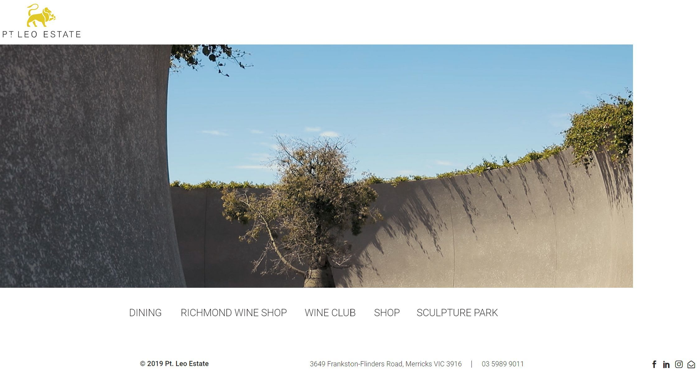
Pt. Leo Estate is a family run ocean front property set on 330 acres of vineyard, farm and sculpture park located in the Mornington Peninsula, Australia.
Opened in October 2017, our philosophy is centered around genuine hospitality, an eye to detail and professional service at every juncture.
Pt. Leo Estate consists of two award-winning restaurants, an award-winning cellar door and wine terrace, and a world class sculpture park.
Behind the scenes of this unique establishment is a highly skilled sales, marketing and events team dedicated to the continued growth of this business.

Situation: Pt. Leo has opened a new restaurant in Bordeaux. You are a strong, sales focused individual to whom Pt. Leo has asked to lead the sales, marketing and events team in growing their brand exposure in France. You introduce your plan.
Take the following hints into account:
- Plan to contact potential clients to establish rapports and arrange meetings
- Present how you will develop the regional brand awareness and reputation of the restaurants, the sculpture park and the wine label
- Devise a plan to develop the Wine Club in France.

Sources: Mornington Peninsula Wineries - Pt Leo Estate - Wine Jobs Melbourne Victoria Business Development Manager (winejobsaustralia.com) -

8. Tourism and Wine vacations / wine holidays – Business development manager - Examiner
Business Development Manager Job Description

The Business Development Manager (BDM) is often the first point of contact a new potential client will have with a business when they are seeking information on the products and services the company provides. The BDM also responds to RFP's, tenders, and develops sales in new sales territories.

Business Development Manager Job Description Template
Due to a promotion in our team, we are hiring another Business Development Manager to take over a mix of existing accounts and new sales territory. To excel in this role you should be an active listener, have a compelling sales personality, and a hunger to chase and close new business from cold calls and inbound warm leads.

Business Development Manager Responsibilities:
- Contacting potential clients to establish rapport and arrange meetings.
- Planning and overseeing new marketing initiatives.
- Researching organizations and individuals to find new opportunities.
- Increasing the value of current customers while attracting new ones.
- Finding and developing new markets and improving sales.
- Attending conferences, meetings, and industry events.
- Developing quotes and proposals for clients.
- Developing goals for the development team and business growth and ensuring they are met.
- Training personnel and helping team members develop their skills.

Business Development Manager Requirements:
- Bachelor’s degree in business, marketing or related field.
- Experience in sales, marketing or related field.
- Strong communication skills and IT fluency.
- Ability to manage complex projects and multi-task.
- Excellent organizational skills.
- Ability to flourish with minimal guidance, be proactive, and handle uncertainty.
- Proficient in Word, Excel, Outlook, and PowerPoint.
- Comfortable using a computer for various tasks.

Source: Wine Jobs Melbourne Victoria Business Development Manager (winejobsaustralia.com)

9. Tourism and Wine vacations / wine holidays - Event manager

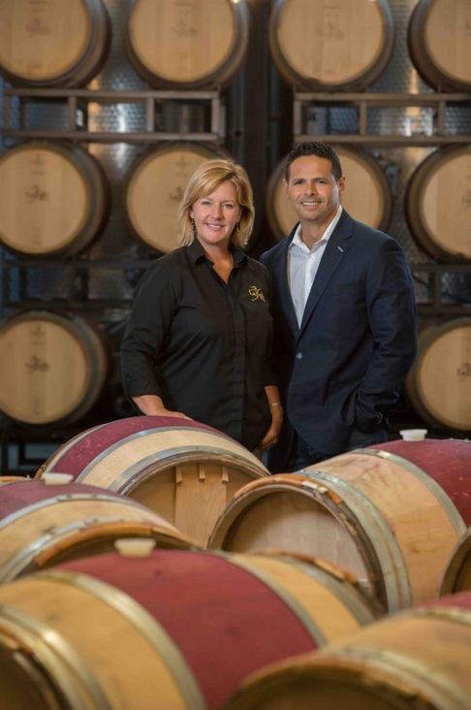
Our History
This special place began as a dream of mine in 2001 – a dream that happened as I visited a small winery in Nova Scotia Canada. The moment I walked into that winery, I had a “lightning bolt” moment, and I knew that I was meant to make wine. So, I began learning the art of winemaking first at home in my small Boston apartment, and then at UC Davis, California in their distance learning program, and I was hooked.
In 2005, I had met and married my dear husband, Cesar Arboleda, and we embarked on our journey to build what is now our 20,000 square foot, state of the art, LaBelle Winery, Bistro Restaurant and Event Center.
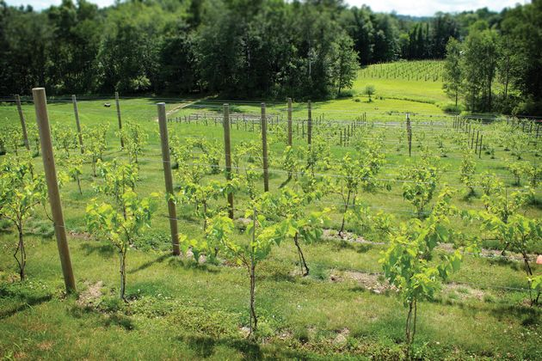
At LaBelle Winery you can taste award-winning wine, learn on a winery and vineyard tour, dine in The Bistro at LaBelle Winery with fresh, organic product straight from The Farm at LaBelle Winery, listen to live music, take a class, stroll through our art gallery, enjoy the gorgeous architecture that evokes New England’s past in a very modern, sleek way, celebrate a special moment, or simply put your feet up and relax with a glass of wine on our terrace while sitting by our fire-bowl.
My husband, Cesar Arboleda, and I invite you to visit LaBelle Winery. We can’t wait to share our dream with you…. Welcome to the LaBelle Winery Family!
Best wishes,Amy and Cesar
The Vineyard

Our winery has six different grape varieties planted on about two acres of land. The varieties were selected in part because of their ability to ripen early in the fall and to survive cold winters. About 1,500 grape vines were planted on the site in June 2012, and another 500 plants were added in Spring 2013. In 2015, they will produce a crop that can be used to make wine.
Awards & Competitions
We send our wines to various national and international competitions every year.
Fruit Sources
Our wine is made from fruit native to New England and the Northeast. Below are some of the farms, orchards and vineyards that supply our fruit.

Situation: You are an event manager and you want to offer your services to the Labelle winery. You plan to stage an event to promote them to a network of French influencers.

Take the following hints into account:
- Devise a set of requirements to select the influencers who will promote the restaurant and the winery.
- Make sure that the Labelle winery will provide enough food and wine for the tasting
- Plan a two-days tour, including hosting and transportation for the influencers coming from France

Source: LaBelle Winery, NH

10. Tourism and Wine vacations / wine holidays - Wine club/e-business manager
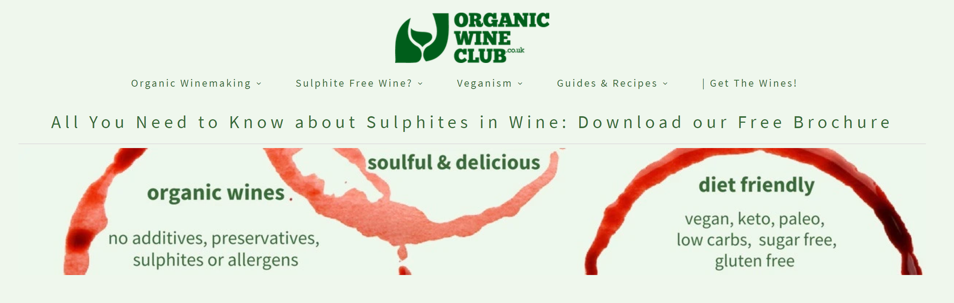
Organic Wine Club (UK) is an independent niche wine retailer focusing on organically made and multi diet friendly wines. We have expertly handpicked organic* wines made with no added sulphites, additives, preservatives and allergens. We are the UK’s first health conscious wine shop.
Big winemaking corporations can use over 50 different additives which are allowed within EU wine production including sugars, sulphites (sulfites), preservatives, colourants and flavour adjustment agents and more. They can trigger allergic reactions, wine-allergy like symptoms, headaches, hangovers and other ill effects.

At Organic Wine Club, we expertly handpick our wines to be:
- organic, organically made or biodynamic, so you won't consume any residual herbicides or pesticides;
- made with low sulphur as we try to source wines that contain 45 mg/l or less. Some have no added sulphites at all, so people suffering from asthma or wine allergy can consider wine again;
- vegan friendly as they're ethically made and contain no traces of dairy, eggs, fishbones or cow's intestines;
- diet friendly after being made without additives, so they are perfect for paleo, keto, low carb diets;
- have a very low residual sugar level, or statistically sugar-free wines, as we try to source wines with no added sugars wherever possible.

Provided that you drink responsibly, our wines have the added bonus of skipping the headaches or 'morning after effects' too, as this feeling can often be triggered by the excessive levels of sulphites, sugars or additives. We are certain that you will would be happy you knew us the morning after the night before!
Have a look at our member reviews: our wine club members are sharing their opinions on better mornings, no hangovers and being able to run with energy the next day.

Situation: You are the new Organic Wine club manager. Sales have been down because of the COVID-19 crisis and the board has asked you a presentation of your plan to increase the wine club sales.

Take the following hints into account:
- Devise a plan to get new members for the wine club.
- Present your initiatives to increase brand loyalty and sales for regular customers.
- Introduce your marketing plan concerning events and promotions

10 bis. Tourism and Wine vacations / wine holidays - Wine educator / Tour guide / Wine club manager -Examiner

Hospitality and Retail Wine Jobs

As tasting room manager, you would be in charge of hiring, training and supervising the tasting room staff. Further, it would be your responsibility to monitor the tasting room goals and to devise strategies to exceed those goals. Although you would be conducting tours, it is more important that you properly train your staff to carry out these tours.
A fantastic way to get your start in the wine industry is as a tasting room associate. In this position the duties and responsibilities would include conducting tours for groups up to 50 people, conducting tasting for large groups, an ability to display and convey knowledge of wine, and assisting with customer purchases of wine. WineBusiness.com states an average salary of $24,000-$30,000; however, this usually comes with big bonus structures which can boost the overall income greatly. The requirements for this entry level position are the ability to speak with confidence and accuracy in front of large groups, a passion for wine and customer service, and energetic and professional qualities to represent the wine brand.
Although a similar job to a tasting room manager, the position of wine club manager focuses more on developing an actual wine club for the winery. This manager would be in charge of marketing for that club, getting new members, and planning events for the club. The requirements are typically a Bachelor’s degree, superior event planning skills, and experience in a similar field. The average salary according to WineBusiness.com for this position averages to about $50,000 per year.
The job of Wine Club Manager is a combination of customer service and sales. You might be employed by an individual winery and sell only their wines, or you might work with an organization offering a variety of wines. Like any Salesperson, you have to hit your numbers. In this case, that’s the number of people who sign up and stay with the club.
You do a lot of marketing (like emailing flyers or holding promotions), and attend conferences or throw events to get your club’s name out there. You might do themed boxes of wine (all reds!), or send detailed information that lets customers know about the wine’s history or what foods they should pair with it.

Although most opportunities are similar to a tasting room associate, some positions do exist within tour groups as a wine tour guide. As a wine tour guide, you would get to travel with your group all over the wine area you were covering. If you like to travel and truly enjoy meeting new people, this may be a career for you to consider. Conducting wine tours requires a great deal of expertise on the specific wineries and area you are touring…as well as acceptance for the low pay it will typically offer.
One other type of position is referred to as a sommelier, or a wine expert that typically exists in a fine dining restaurant. While others can use this title, the job description for one in a restaurant includes the upkeep of the wine collection in the cellar as well as giving customers recommendations on different wines to choose with their meal. The pay will vary by restaurant, but truly this person must enjoy what they do. To become a sommelier, generally one must attend a school and get certified.
Source: Types of Wine Employment from Wine Tour Guides to Sommelier Jobs (jobmonkey.com) - Wine Club Manager Salary and Career Advice | Chegg Careermatch

11. Innovations (communications and transport – sustainable development) - Car sales representative (sujet 0)
Model 3


Model 3 is a small, simple and affordable electric car. Designed and built as the world’s first mass-market electric vehicle, it is a critical step in Tesla’s mission to accelerate the world’s transition to sustainable energy. Like every Tesla vehicle, Model 3 combines range, performance, safety and technology. Model 3 is currently in production. Deliveries begin Mid 2019
STANDARD EQUIPMENT Base Price - $35,000

Standard Battery
- Range: 220 miles (EPA estimated)
- Supercharging rate: 130 miles of range per 30 minutes
- Home charging rate: 30 miles of range per hour (240V outlet, 32A)
Performance
- 0-60 mph: 5.6 seconds
- Top speed: 130 mph
Interior
- 15” touchscreen display
- Dual zone climate control system
- Front center console with open storage and
two USB ports

Convenience
- Maps and navigation with real-time traffic-based routing
- Wi-Fi and cellular internet capability
Safety
- Eight cameras, forward radar and twelve ultrasonic sensors enabling active safety technologies including collision avoidance and automatic emergency braking
- Child safety locks
- Anti-theft alarm system
Warranty
- Vehicle: 4 year/ 50,000 miles warranty
- Battery warranty: 8 year, 100,000 mile (120,000 mile with Long Range Battery)
OPTIONS
Model 3 can be customized with various options and packages, and is available in a number of different configurations, including Dual-Motor All-Wheel Drive for superior performance and traction in any weather and Model 3 Performance for best-in-class acceleration. Please visit our Design Studio to see all currently available options and specifications for Model 3. https://www.tesla.com/fr_FR/presskit#model3

SITUATION:
You work as a sales advisor at Tesla and have a meeting with a potential customer who is hesitating to buy your Model 3. Prepare your arguments to reassure and convince him/her and satisfy his/her needs. He/she is worried about:
  - Its autonomy and the battery charging rate
  - The delivery time /availability
  - The after sales service / maintenance
  - The price of options

12. Innovations (communications and transport – sustainable development) - Logistics manager

5G is all set and ready to transform industries and society as we know them. Evolving networks to cater for everything from smartphones to robots on factory floors requires high-performing, highly reliable connectivity. That’s why we’ve built a flexible Ericsson 5G platform, enabling service providers to embrace opportunities and challenges, and offer new services for a whole range of new users and industries.

We are proud to be supporting our pioneering partners with their 5G switch. Ericsson is the first company to launch live commercial 5G networks on four continents. Today, 70 percent of the top service providers evaluated in global public 4G network tests use Ericsson’s radios and basebands, which are the key to 5G performance. Our Core solutions are supporting 2.5 billion subscribers from 2G to 5G, representing one-third of the global population. And thanks to our ongoing interoperability engagements with six out of six chipset vendors, our 5G technology is evolving continuously to support a variety of 5G devices. That way, we can cater to the wide-ranging 5G use cases of today and tomorrow.

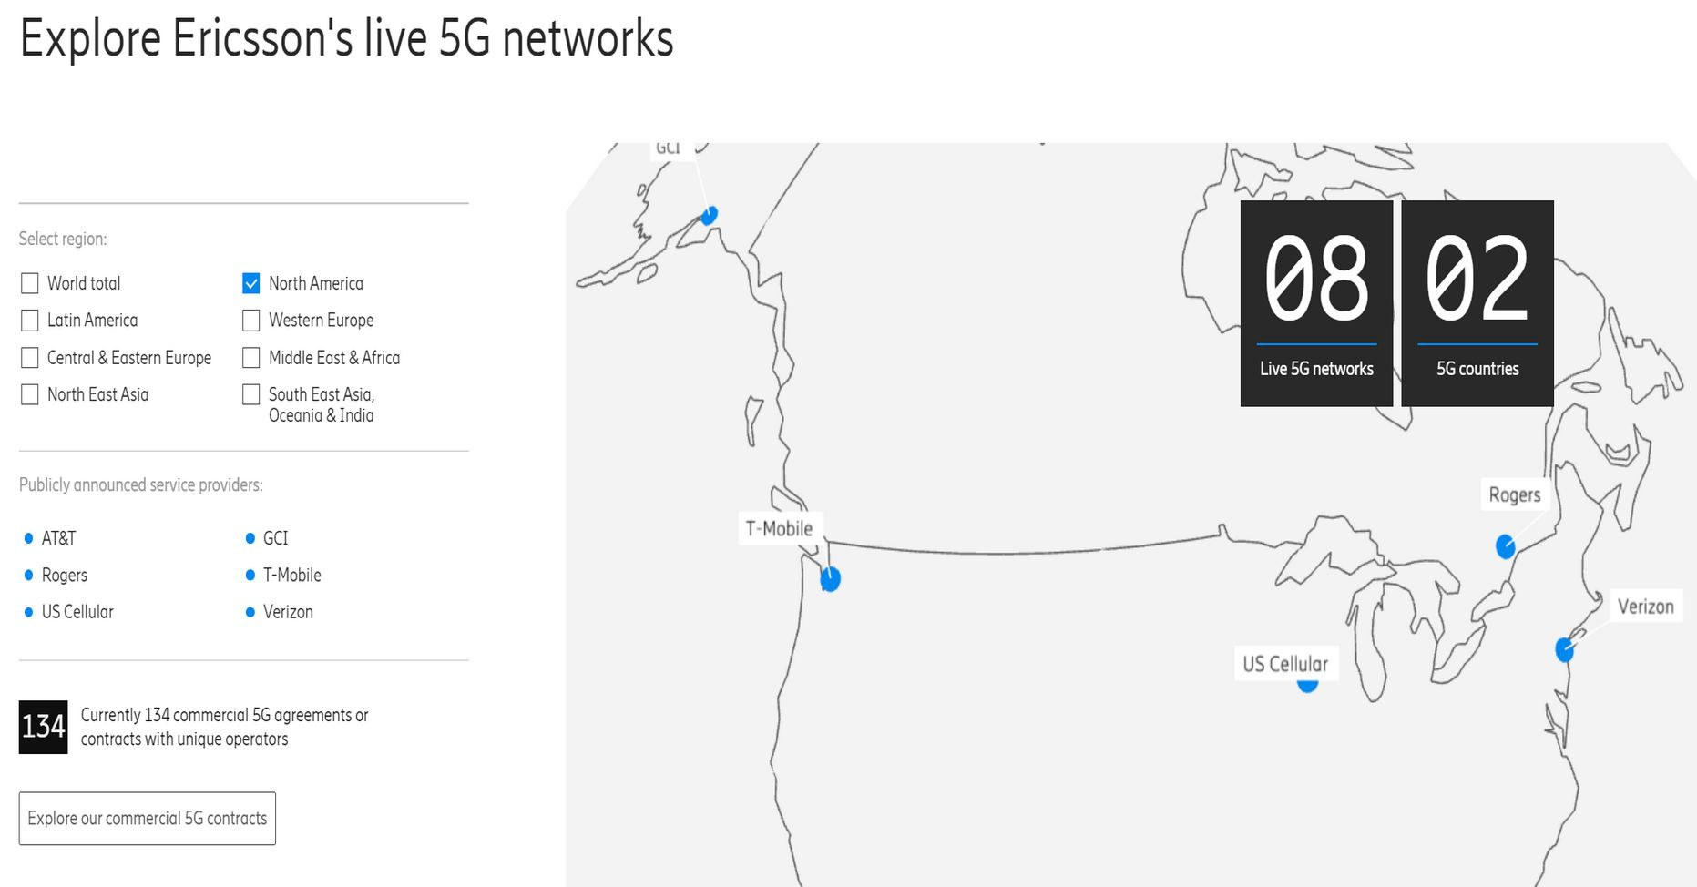
5G gives communication service providers the ability to serve a multitude of use-cases and use-places with lightning fast connectivity. From smart phones to smart factories, 5G is the open innovation platform that enables society to take the leap towards a smarter, safer and sustainable future. Since April 2019, Ericsson's 5G technology is a part of 5G networks across 5 continents, pushing the boundaries of connectivity to break new ground.

Situation: You are a representative for Ericsson and you meet the Los Angeles town council. You want them to authorize the Ericsson company to implement a network for T-Mobile.

Take the following hints into account:
- Provide a demonstration that a 5G network will help the city’s businesses to develop thanks to new use-cases.
- Inform the town council about concerns regarding security breaches and the exposition to high-frequency spectrum waves that have appeared recently.
- Use the company’s brand awareness to secure a contract with the town.

13. Innovations (communications and transport – sustainable development) - sales representative


About this item
- Top VR gaming library: Blast, slash and soar your way through the top library in VR gaming. Oculus Rift S lets you play hundreds of games and exclusives already available in the Oculus store, with so much more to come.
- Improved optics: Stare down the competition with next-generation lenses and a sharper display. Improved optics deliver bright, vivid colors and reduced “screen-door” effect.
- Ergonomic design: Keep your head in the game thanks to a Halo headband redesigned with speed in mind. Rift S stays securely and comfortably in place with a quick twist of the fit wheel, so it can take-or double take-your fastest reactions.
- Oculus touch controllers: Arm yourself with our updated Oculus touch controllers. Your slashes, throws and grab appear in VR with intuitive, realistic precision, transporting your hands and gestures right into the game.
- Oculus insight tracking: take a step forward with Oculus insight. It translates your movements into VR No matter which way you're facing and provides room-scale tracking without external sensors.
- Oculus Rift S requires your Facebook account to log in, making it easy to meet up with friends in VR and discover communities around the world.

Situation: Marks & Spencer has bought a small number of Oculus Rift S to test their attractiveness among their customers. You are asked to write a newsletter.

Take into account the following hints:
- Identify your customer base.
- List the assets of the product.
- How would you make the newsletter attractive and efficient?
Source: Amazon.com: Oculus Rift S PC-Powered VR Gaming Headset: Video Games

14. Innovations (communications and transport – sustainable development) - sales representative
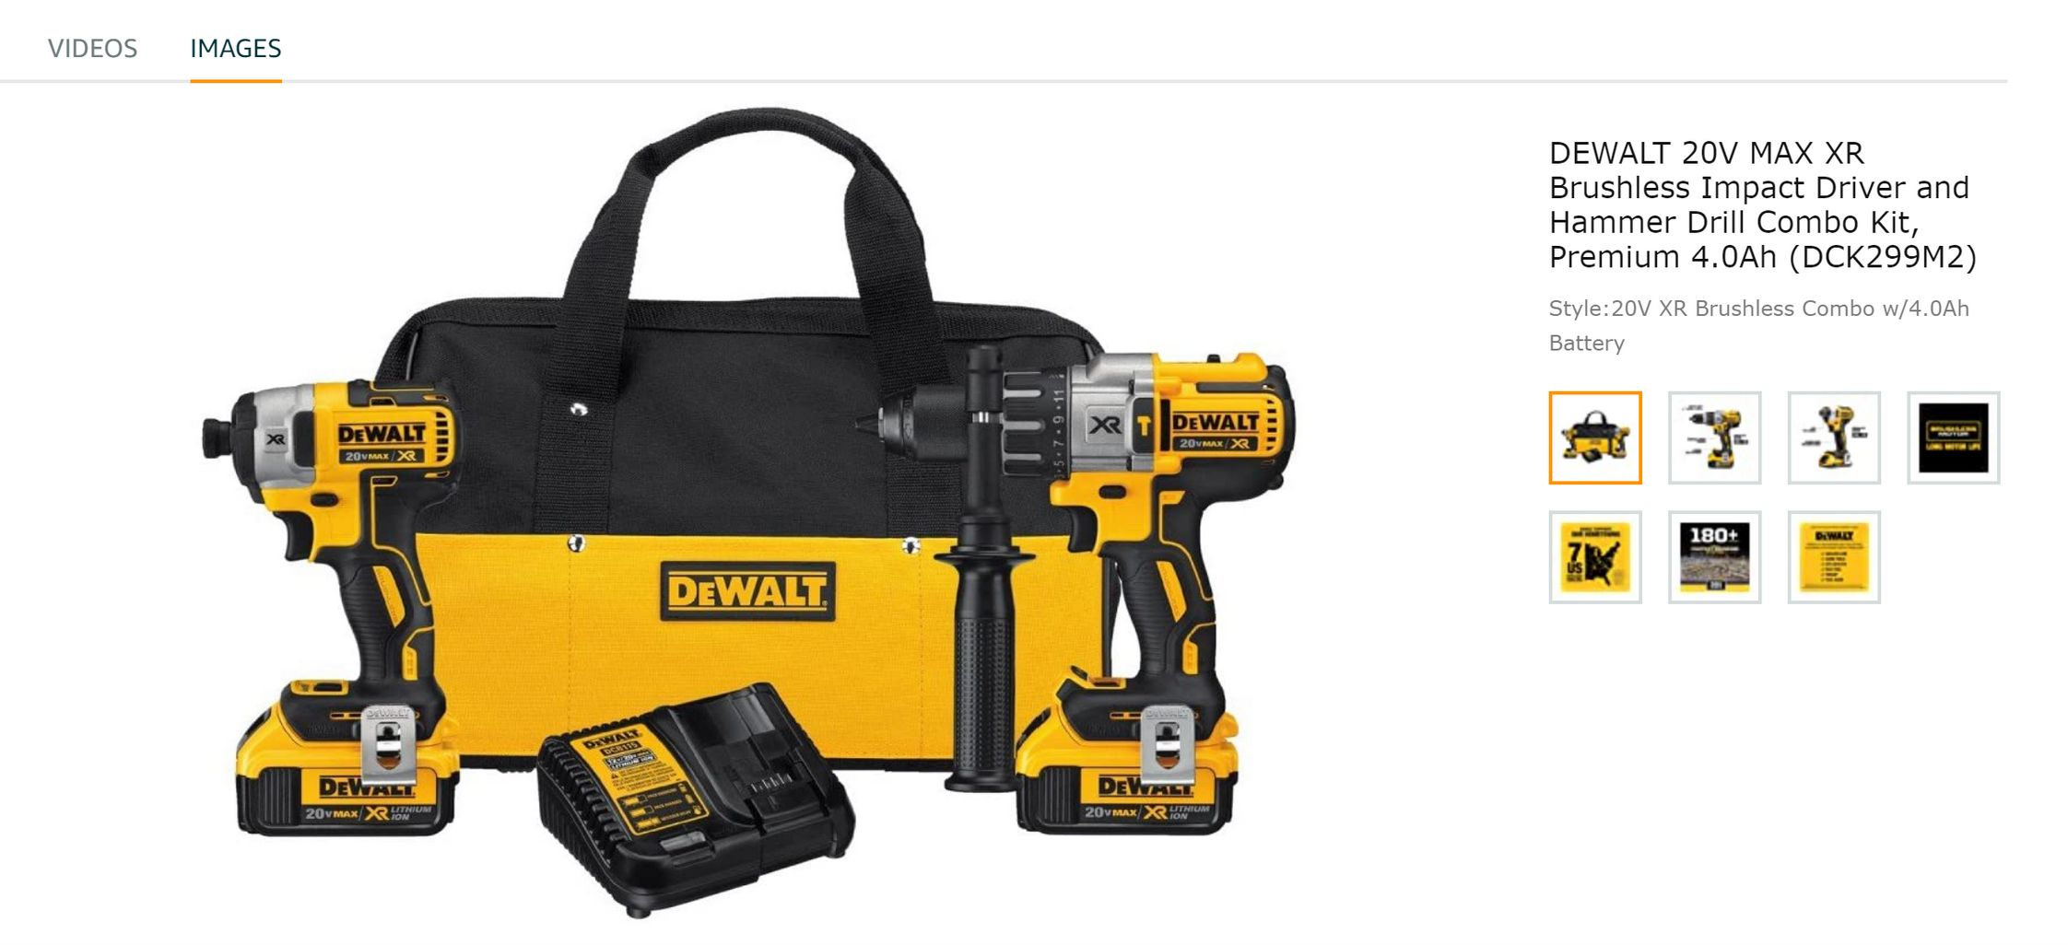
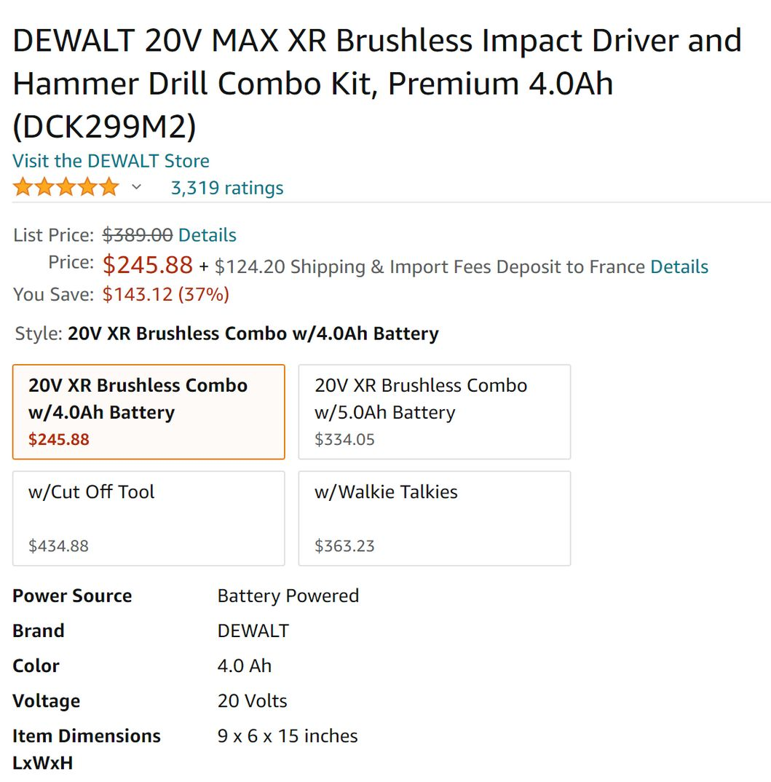
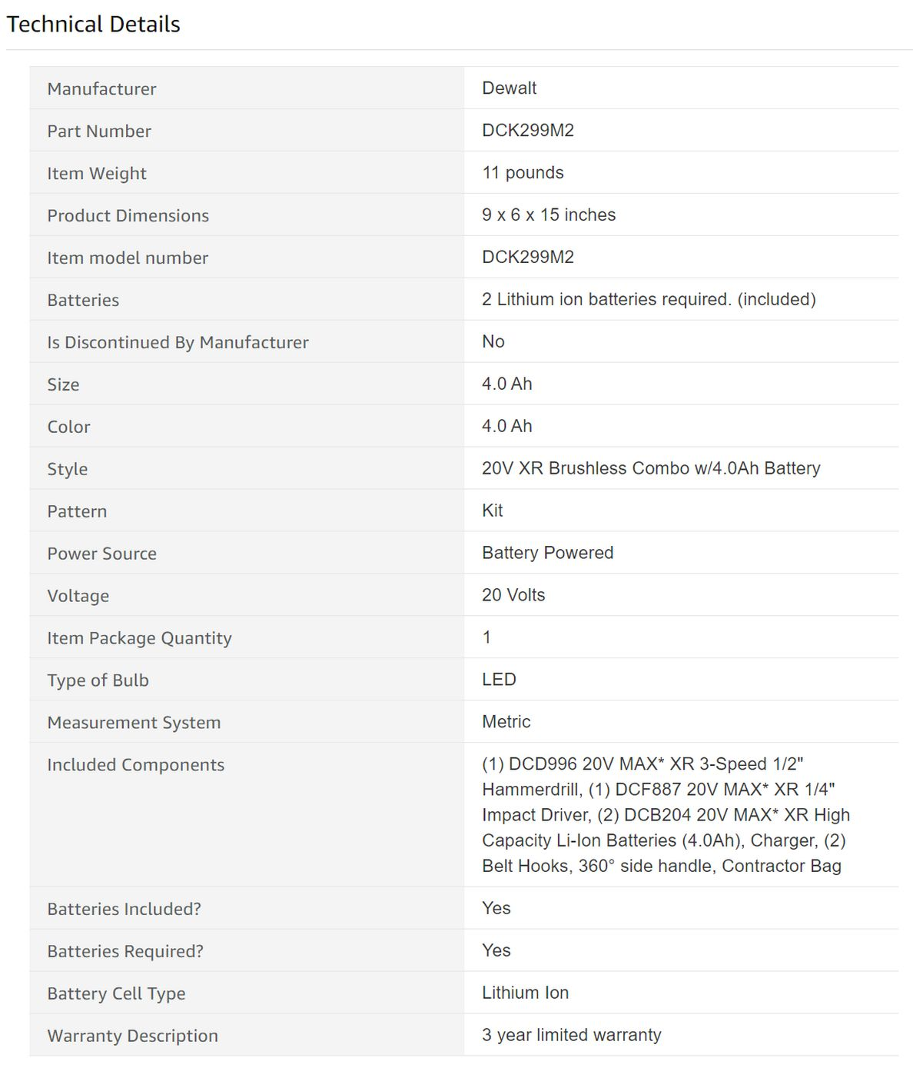
Situation: You are an e-commerce retailer and desire to increase your sales. You settle a marketing strategy on your website.

Take into account the following hints:
- Implement a marketing automation campaign thanks to trackers.
- Plan how you would react to a bad buzz linked to the production of the batteries.
- Increase your visibility thank to your SEO

Source: DEWALT 20V MAX XR Brushless Impact Driver and Hammer Drill Combo Kit, Premium 4.0Ah (DCK299M2) - - Amazon.com

