http://www.skwirk.com/p-c_s-54_u-251_t-647_c-2411/camera-shots-angles-and-movement-lighting-cinematography-and-mise-en-scene/nsw/camera-shots-angles-and-movement-lighting-cinematography-and-mise-en-scene/skills-by-text-type-film/film-overview

Use the pictures on the next page to indicate numbers

Camera Shots

A camera shot is the amount of space that is seen in one shot or frame. Camera shots are used to demonstrate different aspects of a film's setting, characters and themes. As a result, camera shots are very important in shaping meaning in a film. Reviewing the examples should make the different camera shots clearer.

____ An extreme long shot contains a large amount of landscape. It is often used at the beginning of a scene or a film to establish general location (setting). This is also known as an establishing shot.

_____ A long shot contains landscape but gives the viewer a more specific idea of setting. A long shot may show the viewers the building where the action will take place.

_____ A full shot contains a complete view of the characters. From this shot, viewers can take in the costumes of characters and may also help to demonstrate the relationships between characters.

_____ A mid shot contains the characters or a character from the waist up. From this shot, viewers can see the characters' faces more clearly as well as their interaction with other characters. This is also known as a social shot

_____ A close-up contains just one character's face. This enables viewers to understand the actor's emotions and also allows them to feel empathy for the character. This is also known as a personal shot.

_____ An extreme close-up contains one part of a character's face or other object. This technique is quite common in horror films, particularly the example. This type of shot creates an intense mood and provides interaction between the audience and the viewer.

When analysing a film you should always think about the different camera shots and why they are being used. The next time that you are at the cinema or watching television see what camera shots are being used. Important: These camera shots are used in all forms of visual texts including postcards, posters and print advertisements.

Camera angles

It is important that you do not confuse camera angles and camera shots. Camera shots are used to demonstrate different aspects of setting, themes and characters. Camera angles are used to position the viewer so that they can understand the relationships between the characters. These are very important for shaping meaning in film as well as in other visual texts.

The following examples will help you to understand the differences between the different camera angles

_____ A bird's eye angle is an angle that looks directly down upon a scene. This angle is often used as an establishing angle, along with an extreme long shot, to establish setting.

_____ A high angle is a camera angle that looks down upon a subject. A character shot with a high angle will look vulnerable or small. These angles are often used to demonstrate to the audience a perspective of a particular character. The example demonstrates to us the perspective or point of view of a vampire. As a viewer we can understand that the vampire feels powerful.

_____ An eye-level angle puts the audience on an equal footing with the character/s. This is the most commonly used angle in most films as it allows the viewers to feel comfortable with the characters.

_____ A low angle is a camera angle that looks up at a character. This is the opposite of a high angle and makes a character look more powerful. This can make the audience feel vulnerable and small by looking up at the character. This can help the responder feel empathy if they are viewing the frame from another character's point of view.

As with camera shots, you will be able to see many examples of camera angles in any film or visual text that you view. The next time that you watch television or see a film, take note of the camera angles and think of how they affect your perception (idea) of different characters.

_____ Another camera angle that you might come across is a Dutch angle. A Dutch angle is used to demonstrate the confusion of a character. The example should disorientate you.
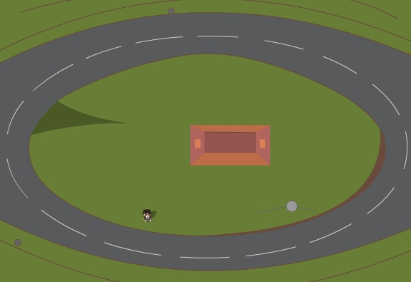  1 | 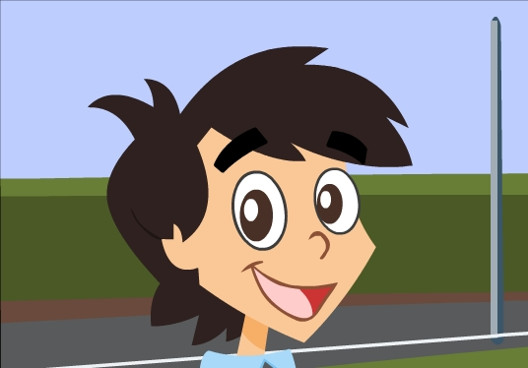  2 | 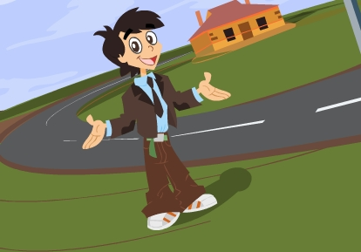  3
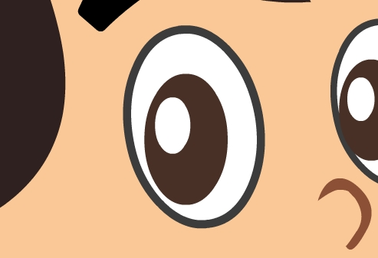  4 | 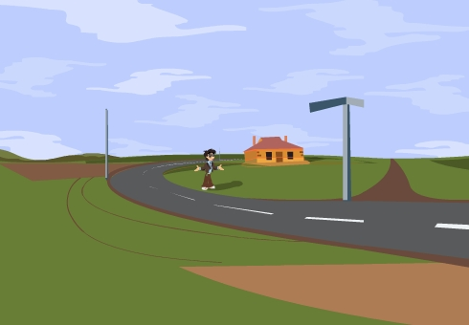  5 | 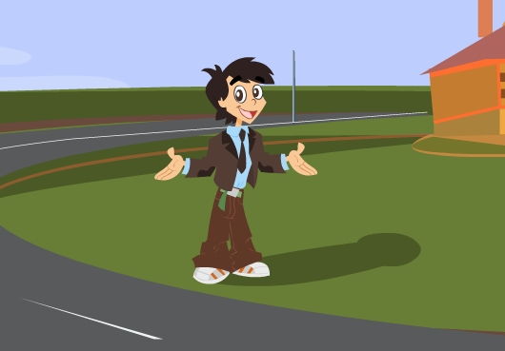  6
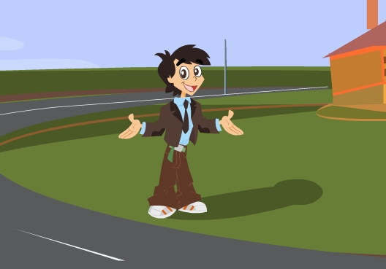  7 | 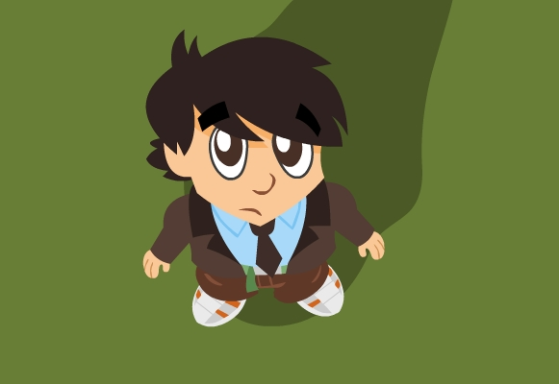  8 | 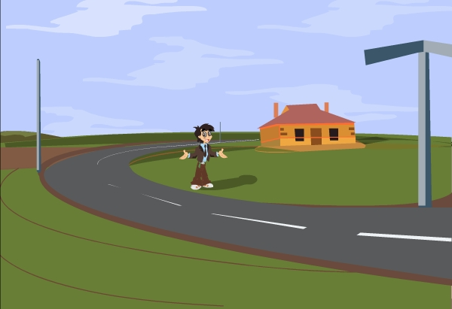  9
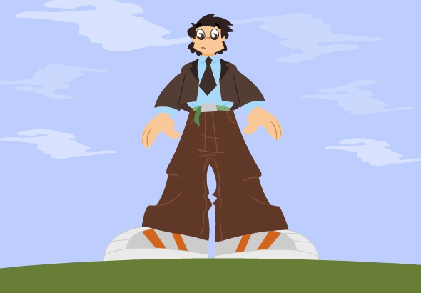  10 | 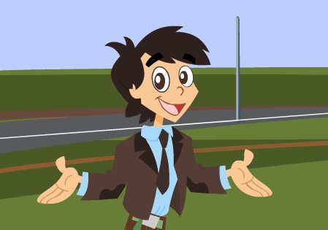  11

Use the pictures on the next page to indicate numbers - PROF

Camera Shots

A camera shot is the amount of space that is seen in one shot or frame. Camera shots are used to demonstrate different aspects of a film's setting, characters and themes. As a result, camera shots are very important in shaping meaning in a film. Reviewing the examples on the next page should make the different camera shots clearer.

__5__ An extreme long shot contains a large amount of landscape. It is often used at the beginning of a scene or a film to establish general location (setting). This is also known as an establishing shot.

___9 __ A long shot contains landscape but gives the viewer a more specific idea of setting. A long shot may show the viewers the building where the action will take place.

__6 / 7___ A full shot contains a complete view of the characters. From this shot, viewers can take in the costumes of characters and may also help to demonstrate the relationships between characters. For more information on costumes and acting refer to Chapter 4.

__11 ___ A mid shot contains the characters or a character from the waist up. From this shot, viewers can see the characters' faces more clearly as well as their interaction with other characters. This is also known as a social shot

__2 ___ A close-up contains just one character's face. This enables viewers to understand the actor's emotions and also allows them to feel empathy for the character. This is also known as a personal shot.

__ 4 __ An extreme close-up contains one part of a character's face or other object. This technique is quite common in horror films, particularly the example above. This type of shot creates an intense mood and provides interaction between the audience and the viewer.

When analysing a film you should always think about the different camera shots and why they are being used. The next time that you are at the cinema or watching television see what camera shots are being used. Important: These camera shots are used in all forms of visual texts including postcards, posters and print advertisements.

Camera angles

It is important that you do not confuse camera angles and camera shots. Camera shots are used to demonstrate different aspects of setting, themes and characters. Camera angles are used to position the viewer so that they can understand the relationships between the characters. These are very important for shaping meaning in film as well as in other visual texts.

The following examples will help you to understand the differences between the different camera angles

___1 __ A bird's eye angle is an angle that looks directly down upon a scene. This angle is often used as an establishing angle, along with an extreme long shot, to establish setting.

__ 8 ___ A high angle is a camera angle that looks down upon a subject. A character shot with a high angle will look vulnerable or small. These angles are often used to demonstrate to the audience a perspective of a particular character. The example above demonstrates to us the perspective or point of view of a vampire. As a viewer we can understand that the vampire feels powerful.

__ 6/7 __ An eye-level angle puts the audience on an equal footing with the character/s. This is the most commonly used angle in most films as it allows the viewers to feel comfortable with the characters.

___10 __ A low angle is a camera angle that looks up at a character. This is the opposite of a high angle and makes a character look more powerful. This can make the audience feel vulnerable and small by looking up at the character. This can help the responder feel empathy if they are viewing the frame from another character's point of view.

As with camera shots, you will be able to see many examples of camera angles in any film or visual text that you view. The next time that you watch television or see a film, take note of the camera angles and think of how they affect your perception (idea) of different characters.

___3 __ Another camera angle that you might come across is a Dutch angle. A Dutch angle is used to demonstrate the confusion of a character. The example should disorientate you.
1 – bird's eye angle | 2 - close-up | 3 - dutch-angle
4 – extreme close-up | 5 – extreme long shot | 6 – eye-level angle
7 – full shot | 8 – high angle | 9 – long shot
10 – low angle | 11 – mid shot

